

Design and Implementation of Voice Controlled Application For Finance (Finansis)

Student ID: 18511510019

name: Mohamed Mohamud Mohamed Nur

Major: Computer science and Technology

College: College of Computer science and Artificial Intelligence

MOAHEMD MOAHMUD MOHAMED NUR 18511510019 of 2018 CS

College of Computer and Artificial Intelligence

A thesis submitted in partial satisfaction of the requirements

For The Degree of Bachelor in

Computer Science and Technology

Supervisor WU WINGO

May 2022

I Mohamed NUR with student id 18511510019 hereby declare that the Work presented in this thesis is original and carried out by myself, under the supervisor of WU WINGO, and with the help of people that provide free information on the internet (stack-overflow and YouTube) during the period 11 /2021 - 5/2022. This work presented in this thesis has not been submitted for any other degree.

ABSTRACT

A Voice assistant is a software agent that can perform tasks or services for an individual based on commands or questions, This project is a voice assistant named Finansis, The main problem that Finansis application tries to solve is to help people to have financial freedom. This application is inspired by Siri, (Siri is a virtual assistant that is part of Apple Inc.'s iOS). Finansis is developed for traders or normal people that interested in the stock market. The system is a web application that can be accessed through the internet. This system can be used for knowing the stock market news (real-time news), knowing current a stock price (real-time price), knowing stock information, showing a stock chart, asking questions related to the stock market, back-testing a trading strategy, and the most interesting is using Algorithmic Trading to trade stocks. This project is build using the MERN stack technologies (MongoDB, Express, React, Node).

**Keywords:** Voice assistant; Stock Market; Algorithmic Trading; Automation.

TABLE OF CONTENTS

LIST OF TABLES i

LIST OF FIGURES iv

1 INTRODUCTION 1

1.1 System Development Environment Description 3

2 Literature review 5

2.1 Speech recognition 5

2.2 NLP 5

2.3 Speech synthesis 6

2.4 Algorithmic Trading 6

3 Technologies Used To Create Voice Assistant 7

3.1 Background info and pre-requisites 7

3.1.1 Introduction of NodeJS 7

3.1.2 Installation of NodeJS and NPM 7

3.1.3 Introduction of ReactJS 8

3.1.4 Creating ReactJS project using create-react-app 8

3.1.5 Introduction of react-speech-recognition 11

3.1.6 Installation of react-speech-recognition 11

3.1.7 Introduction of react-speech-kit 13

3.1.8 Installation of react-speech-kit 13

3.1.9 Your first voice assistant 16

4 REQUIREMENTS ANALYSIS 19

4.1 Functional requirement 19

5 SYSTEM DESIGN 22

5.1 System structure diagram 23

5.2 Data flow graph 24

5.2.1 The first data flow graph 24

5.2.2 The second data flow graph 24

5.2.3 The third data flow graph 25

5.3 System flow chart 30

5.3.1 Getting news flow chart 30

5.3.2 Asking question flow chart 31

5.3.3 Opening chart flow chart 32

5.3.4 Starting back-testing flow chart 33

5.3.5 Zooming in or out flow chart 35

5.4 Commands description: 36

5.4.1 User management commands (10): 36

5.4.2 Stock Market News commands (10): 36

5.4.3 Stock information commands (9): 37

5.4.4 controlling the app with a voice commands (5): 37

5.4.5 asking questions about the stock market commands: 37

5.4.6 back-testing stock trading strategy commands (4): 37

5.4.7 other commands (10): 38

5.4.8 automating stock trading commands (8): 38

6 SYSTEM PROBLEMS 59

7 Testing 62

8 Conclusion 85

8.1 Future Goals For The System overview 85

8.2 Drawback of Existing system 85

9 REFERENCE 86

LIST OF TABLES

Table 1 Register 19

Table 2 Log in 20

Table 3 forgot (my) password 21

Table 4 update my information 21

Table 5 logout 22

Table 6 logout 22

Table 7 add {Apple|AAPL|...} stock to (my) watch list 23

Table 8 delete {Apple|AAPL|...} stock from (my) watch list 24

Table 9 open (my) watch list 24

Table 10 Give me the news from {yahoo finance|investing|seekingalpha} 25

Table 11 Give me the news from {yahoo finance|investing|seekingalpha} 25

Table 12 what's up with {Apple|China|...} 26

Table 13 Give me the latest news 26

Table 14 read the news 26

Table 15 Give me more news 27

Table 16 start reading (news) from article {1|5|...} 27

Table 17 open article (number) {1|5|...} without control 28

Table 18 give me top stories 28

Table 19 logout 29

Table 20 open {Apple|AAPL|...} (symbol) chart 30

Table 21 give me {Apple|AAPL|...} statistics 30

Table 22 give me The most {actives|gainers|losers} stocks 31

Table 23 give me trending stocks 31

Table 24 open {Apple|AAPL|...} (symbol) chart with your control 32

Table 25 what is the current price for {Apple|AAPL|...} (symbol) 32

Table 26 show me {Apple and Tesla} charts 33

Table 27 go back 34

Table 28 go to {info|news|...} (page) 34

Table 29 close the window 34

Table 30 zoom {in|out} 35

Table 31 change the chart to {1 minute|1 hour|...} 35

Table 32 go forward 35

Table 33 open details page for the answer 36

Table 34 what is market capitalization 36

Table 35 back-testing stock trading strategy commands 37

Table 36 reset back testing (data) 37

Table 37 force sell 38

Table 38 sell with profit or without 38

Table 39 stock (number) {1|5|...} 39

Table 40 what can you do 39

Table 41 what is your name 39

Table 42 (of course) yes 39

Table 43 No 40

Table 44 do you have a boyfriend 40

Table 45 can you hear me 40

Table 46 stop listening 40

Table 47 thank you 41

Table 48 thank you 41

Table 49 buy stocks 42

Table 50 sell stocks 42

Table 51 set stop-loss for stocks 43

Table 52 find buy signals 43

Table 53 trade stocks for me 43

Table 54 show me (a) chart for found buy signals (stocks) 44

Table 55 show me (a) chart for found buy signals (stocks) 44

Table 56 show me trading progress 45

Table 14 User model 47

Table 15 applicant model 48

Table 16 Recruiter model 48

Table 17 Job model 50

Table 18 Rating model 51

Table 19 application model 52

Table 20 Applicant Registration 63

Table 21 Recruiter Registration 64

Table 22 User login 65

Table 23 adding job 66

Table 24 update job info 66

Table 25 viewing Applications 67

Table 26 System Operating Environment Requirements. 68

Table 27 Function1-division 75

Table 28 Function2-division 75

Table 29 Function3-division 75

LIST OF FIGURES

Figure 1 Number of voice assistant users in US 1

Figure 2 nodejs Website 7

Figure 3 nodejs installer 8

Figure 4 react app created successfully 9

Figure 5 before deleting files 9

Figure 6 after deleting files 9

Figure 7 react app running successfully 10

Figure 8 initial project 11

Figure 9 result after installing react-speech-recognition 13

Figure 10 installing react-speech-kit step 1 14

Figure 11 installing react-speech-kit step 2 14

Figure 12 installing react-speech-kit step 3 14

Figure 13 installing react-speech-kit step 4 15

Figure 14 final Result for simple-voice-assistant 18

Figure 15 System structure diagram 23

Figure 16 DFD-1 24

Figure 17 DFD-2FD-2 24

Figure 18 DFD (Back-Testing)-3-1 25

Figure 19 DFD (Questions)-3-2 26

Figure 20 DFD (Stock Info)-3-3 26

Figure 21 DFD (User Management)-3-4 27

Figure 22 DFD (Stock Market News)-3-5 28

Figure 23 DFD (automating trading)-3-6 29

Figure 24 getting news flow chart 30

Figure 25 asking question flow chart 31

Figure 26 opening chart flow chart 32

Figure 27 start back-testing flow chart 34

Figure 28 zooming in or out flow chart 35

# INTRODUCTION

A voice assistant is a digital assistant that uses voice recognition, language processing algorithms, and voice synthesis to listen to specific voice commands and return relevant information or perform specific functions as requested by the user.

Based on specific commands, sometimes called intents, spoken by the user, voice assistants can return relevant information by listening for specific keywords and filtering out the ambient noise.

While voice assistants can be completely software based and able to integrate into most devices, some assistants are designed specifically for single device applications, such as the Amazon Alexa Wall Clock.

Today, voice assistants are integrated into many of the devices we use on a daily basis, such as cell phones, computers, and smart speakers. Because of their wide array of interactions, There are several voice assistants who offer a very specific feature set, while some choose to be open ended to help with almost any situation at hand.

Voice technology usage is rising worldwide. In the US alone, the number of people who use voice assistants and smart speakers—including those from Amazon, Google, and Apple—grow by double digits in 2020, fueled largely by stay-at-home behavior during the pandemic.

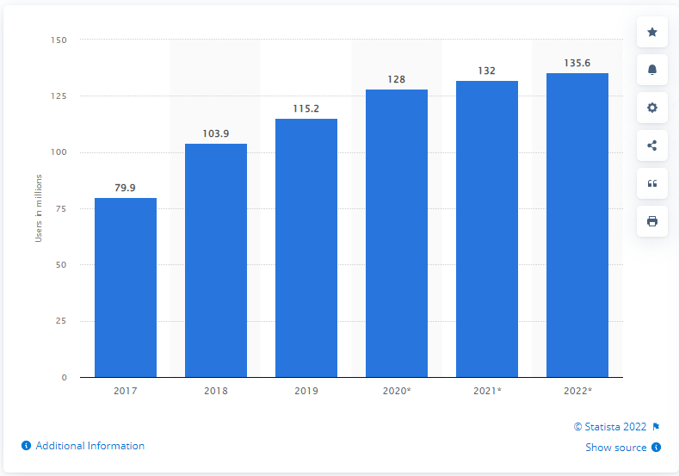

How many people in the US use voice assistants?

We estimate that 128.0 million people in the US will use a voice assistant at least monthly in 2020, up 11.1% from 115.2 million in 2019. This represents 44.2% of internet users and 38.5% of the total population. [12]

Figure 1 Number of voice assistant users in US

This voice assistant project offers a very specific feature set, I named the voice assistant Finansis, Finansis application tries to help people to have financial freedom and to create a passive income for them using the stock market. There are 9 main modules in this voice-controlled application User management, Stock Market News, Stock information, Speech recognition, controlling the app with a voice, Speech synthesis, asking questions about the stock market, back-testing stock trading strategy, and automating stock trading. there are 59 commands that Finansis understand plus stock related questions (for example 'what is market capitalization') and Finansis can ask more than 14 yes/no questions and then respond and do something based on a user's answer lastly, Finansis can ask a user to choose a stock from a list of stocks. Finansis has the ability to 'learn' about related Stock market questions and Stocks' symbol, actually, Finansis just search in DuckduckGo (a search engine like google) and then save the piece of information in the database. Two mini-projects help Finansis news API, and Trading API, Trading API is a private project, news API is an API to save scraped news in the database and let Finansis retrieve news from the database, and news API is online[13]. There are four python scraping scripts running for 24 hours online, scraping news from yahoo finance, google finance, investing and seeking websites, and all that for free. Finansis uses Yahoo Finance website to show users stocks information.

(scripts url: [14])

## System Development Environment Description

In software, web and mobile application development, the development environment is a workspace with a set of processes and programming tools used to develop the source code for an application or software product. The environments are categorized into groups, including frontend, backend, browser, IDE, Scraping, Automation, operating system, and programming language.

* programming language
  + JavaScript ES6
  + Python 3.8.2
* operating system
  + Windows 10 Version 21H2 (Build 19044.1645)
* Browser
  + Google Chrome 101.0.4951.54 (Official Build) (64-bit) (cohort: Stable)
* IDE
  + Visual Studio Code@1.66.2
* Front-end
  + React@17.0.2
  + Styled-components@5.3.3
  + react-speech-recognition@3.9.0 (Web Speech API)
  + Axios@0.24.0
  + Redux@4.1.2
  + material-ui@4.10.1
* Back-end
  + Axios@0.24.0
  + bcrypt @5.0.1
  + Cors@2.8.5
  + Crypto@1.0.1
  + Dotenv @10.0.0
  + Express@4.17.1
  + Jsonwebtoken@0.2.0
  + Mongoose@6.1.1
  + MongoDB
* Scraping
  + Replit
  + Webbot@0.34
  + BeautifulSoup@4.10.0
* Automation
  + Puppeteer@13.0.0

# Literature review

## Speech recognition

Speech recognition, or speech-to-text, is the ability of a machine or [program](https://www.techtarget.com/searchsoftwarequality/definition/program) to identify words spoken aloud and convert them into readable text. Speech recognition works by breaking down the audio of a speech recording into individual sounds, analyzing each sound, using algorithms to find the most probable word fit in that language, and transcribing those sounds into text [2]. Speech recognition uses natural language processing (NLP) and deep learning neural networks.

## NLP

NLP algorithms are typically based on machine learning algorithms. Instead of hand-coding large sets of rules, NLP can rely on machine learning to automatically learn these rules by analyzing a set of examples (i.e. a large corpus, like a book, down to a collection of sentences), and making a statistical conclusion. In general, the more data analyzed, the more accurate the model will be[3].

## Speech synthesis

Speech synthesis is the computer-generated simulation of human speech. It is used to translate written information into aural information.

How does Speech Synthesis Work? There are 3 stages in which speech synthesis works; text to words, words to phonemes, and phonemes to sound:

* Text to words

The initial stage of speech synthesis, is generally called pre-processing or normalization, it is everything about reducing ambiguity: it’s about narrowing down the many different ways a person could read a piece of text into the one that’s the most appropriate.

* Words to phonemes

Phonemes are one of the smallest units of speech that make one word different from another word. Once they figure out the words that need to be spoken, next the speech synthesizer has to generate the speech sounds that make up these words. Every computer needs is a huge alphabetical list of words and details of how to pronounce each word. For each word, they would need a list of the phonemes that make up its sound.

* Phonemes to sound

At this point, the computer has converted the text into a list of phonemes. But how to find basic phonemes that the computer reads aloud when it’s turning the text into speech. There are three different approaches to this.

* First to use recordings of humans saying the phonemes
* The second is for the computer to generate the phonemes itself by generating basic sound frequencies
* The last approach is to imitate the technique of the human voice

## Algorithmic Trading

Algorithmic trading is a method of executing orders using automated pre-programmed trading instructions accounting for variables such as time, price, and volume. This type of trading attempts to leverage the speed and computational resources of computers relative to human traders [7].

# Technologies Used To Create Voice Assistant

## Background info and pre-requisites

The following few points are designed to get you started with developing rapidly and easily a voice assistant.

### Introduction of NodeJS

NodeJS is an open-source, cross-platform runtime environment for developing server-side web applications. NodeJS also has an event-driven architecture capable of asynchronous I/O.

### Installation of NodeJS and NPM

Installation of NodeJS and NPM is straightforward using the installer package available at NodeJS official web site.

* Download the installer from NodeJS WebSite (https://nodejs.org/en/).

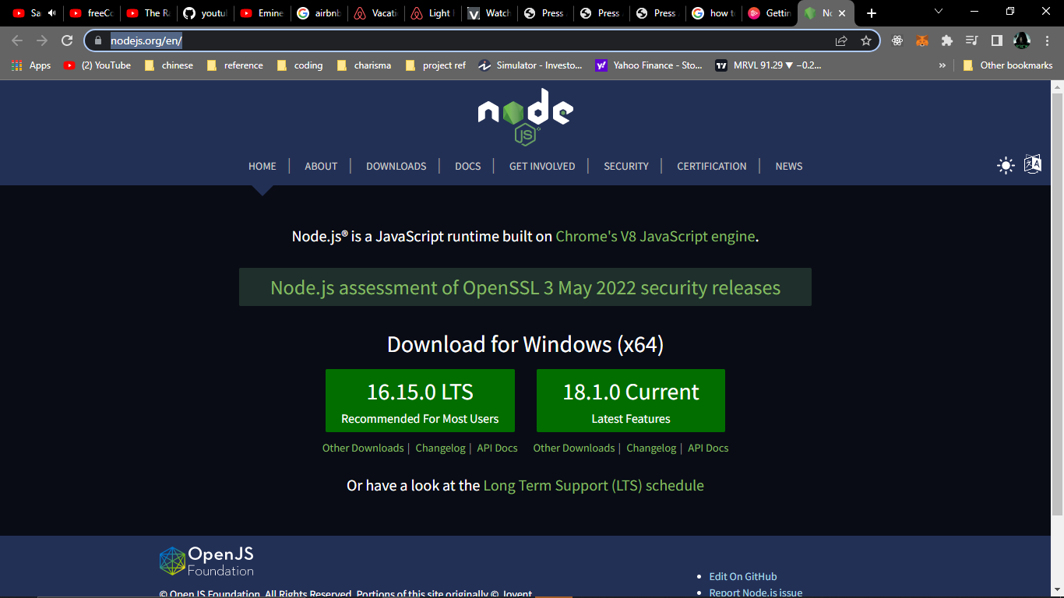

Figure 2 nodejs Website

* Run the installer.

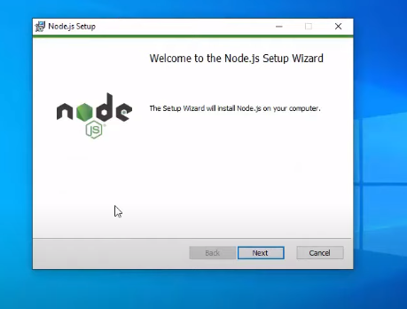

Figure 3 nodejs installer

* Follow the installer steps, agree the license agreement and click the next button

Now, let’s test NodeJS by printing its version using the following command in Command Prompt:

node -v

and test npm by printing its version using command

npm -v

### Introduction of ReactJS

React is a free and open-source front-end JavaScript library for building user interfaces based on UI components, We will use react to build our voice assistant because React makes it painless to create interactive UIs, and interactivity is important when it comes to voice assistant.

### Creating ReactJS project using create-react-app

In this step, you’ll create a new application using the npm package manager to run a remote script. The script will copy the necessary files into a new directory and install all dependencies.

When you installed Node, you also installed a package managing application called npm. Npm will install JavaScript packages in your project and also keep track of details about the project.

npm also includes a tool called npx, which will run executable packages. What that means is you will run the Create React App code without first downloading the project.

The executable package will run the installation of create-react-app into the directory that you specify. It will start by making a new project in a directory, which in this tutorial will be called simple-voice-assistant. Again, this directory does not need to exist beforehand; the executable package will create it for you. The script will also run ‘npm install’ inside the project directory, which will download any additional dependencies

To install the base project, run the following command:

npx create-react-app simple-voice-assistant

If you see the following message then you created react app successfully:

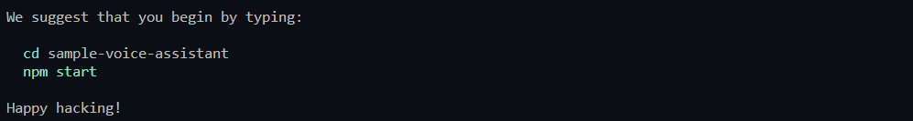

Figure 4 react app created successfully

Now open the project with your favorite IDE, I will use VSCode

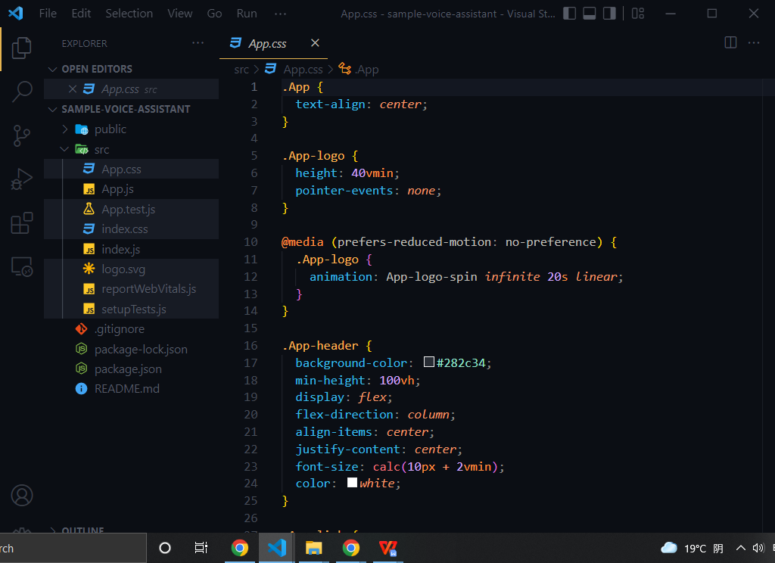

Figure 5 before deleting files

Remove all unnecessary files, only leave App.js and index.js, your folder should look like the following image:

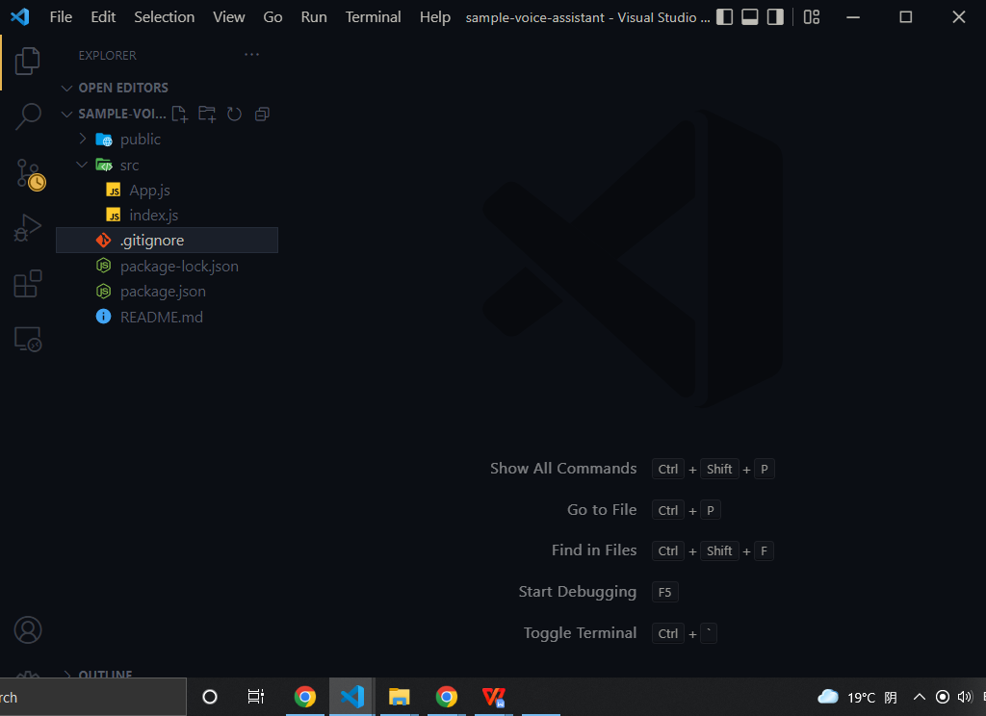

Figure 6 after deleting files

update App.js file like the following code:

function App() {

  return <div>simple voice assistant</div>;

}

export default App;

Update index.js file like the following code:

import React from "react";

import ReactDOM from "react-dom/client";

import App from "./App";

const root = ReactDOM.createRoot(

  document.getElementById("root")

);

root.render(

  <React.StrictMode>

    <App />

  </React.StrictMode>

);

Now run the following command to start react app in your localhost:8000:

npm start

If you see the following message in your command line you ran react project successfully:

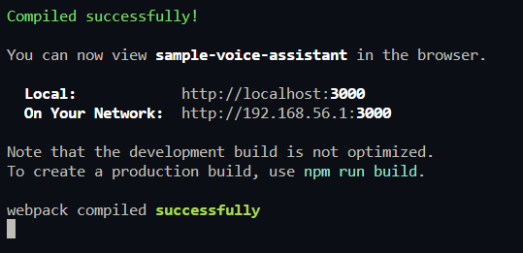

Figure 7 react app running successfully

Let’s check out our project in the browser:

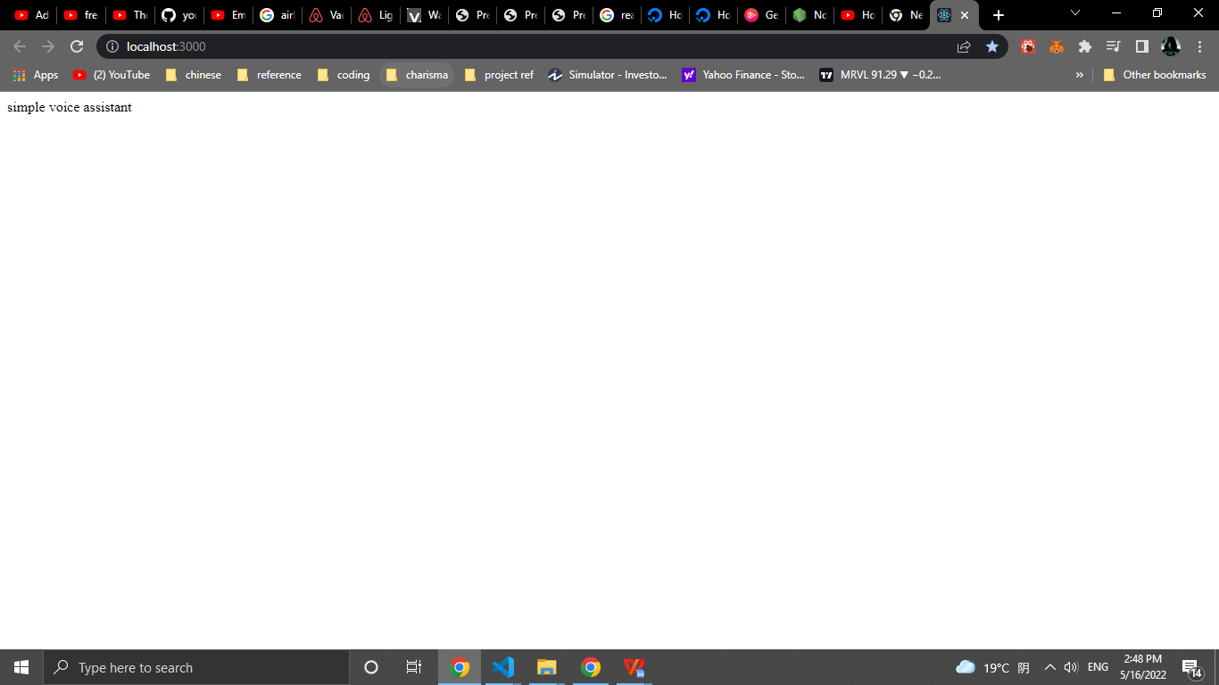

Figure 8 initial project

### Introduction of react-speech-recognition

A React hook that converts speech from the microphone to text and makes it available to your React components.

Under the hood, it uses Web Speech API. Note that browser support for this API is currently limited, with Chrome having the best experience.

### Installation of react-speech-recognition

run the following command to install react-speech-recognition:

npm install react-speech-recognition

Let check out if we installed react-speech-recognition successfully by updating App.js like the following code:

import SpeechRecognition, {

  useSpeechRecognition,

} from "react-speech-recognition";

function App() {

  const {

    transcript,

    listening,

    resetTranscript,

    browserSupportsSpeechRecognition,

  } = useSpeechRecognition();

  if (!browserSupportsSpeechRecognition) {

    return (

      <span>Browser doesn't support speech recognition.</span>

    );

  }

  const commonStyle = {

    display: "flex",

    justifyContent: "center",

    alignItems: "center",

    gap: "10px",

  };

  return (

    <div

      style={{

        ...commonStyle,

        flexDirection: "column",

        height: "100vh",

      }}

    >

      <p>Microphone: {listening ? "on" : "off"}</p>

      <div

        style={{

          ...commonStyle,

        }}

      >

        <button onClick={SpeechRecognition.startListening}>

          Start

        </button>

        <button onClick={SpeechRecognition.stopListening}>

          Stop

        </button>

        <button onClick={resetTranscript}>Reset</button>

      </div>

      <p>{transcript}</p>

    </div>

  );

}

export default App;

Now if you click on Start button and then say ‘can you here me’ you should see something like the following image:

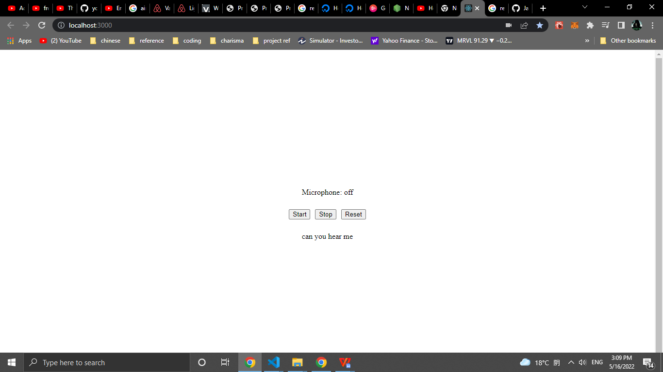

Figure 9 result after installing react-speech-recognition

### Introduction of react-speech-kit

React hooks for in-browser Speech Recognition and Speech Synthesis. We only going to useSpeechSynthesis function from this package.

### Installation of react-speech-kit

Now run the following command to install react-speech-kit:

npm install react-speech-kit

If you had an error like me while installing react-speech-kit so go to <https://github.com/MikeyParton/react-speech-kit/blob/master/src/useSpeechSynthesis.jsx> and copy the code to your project like this:

1. Go to their GitHub

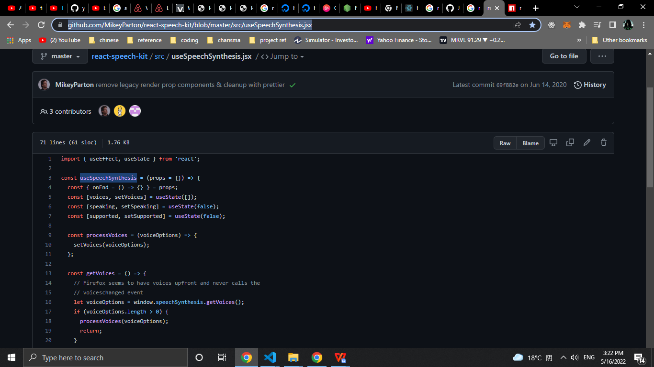

Figure 10 installing react-speech-kit step 1

1. Click on copy button

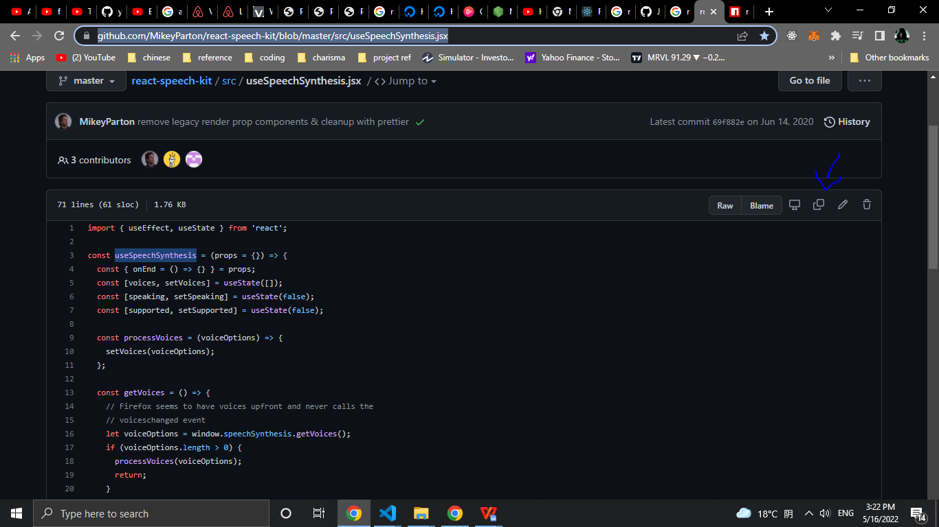

Figure 11 installing react-speech-kit step 2

3 - create new file in your project called useSpeechSynthesis:

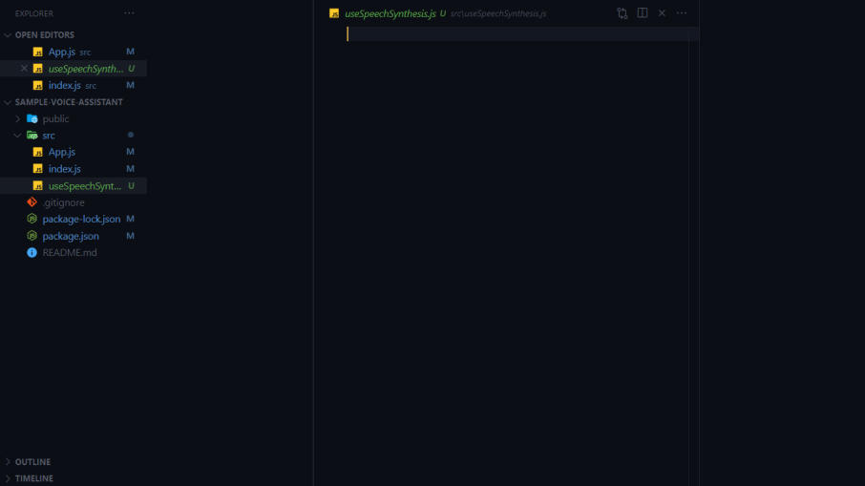

Figure 12 installing react-speech-kit step 3

4 - pass their code in useSpeechSynthesis file:

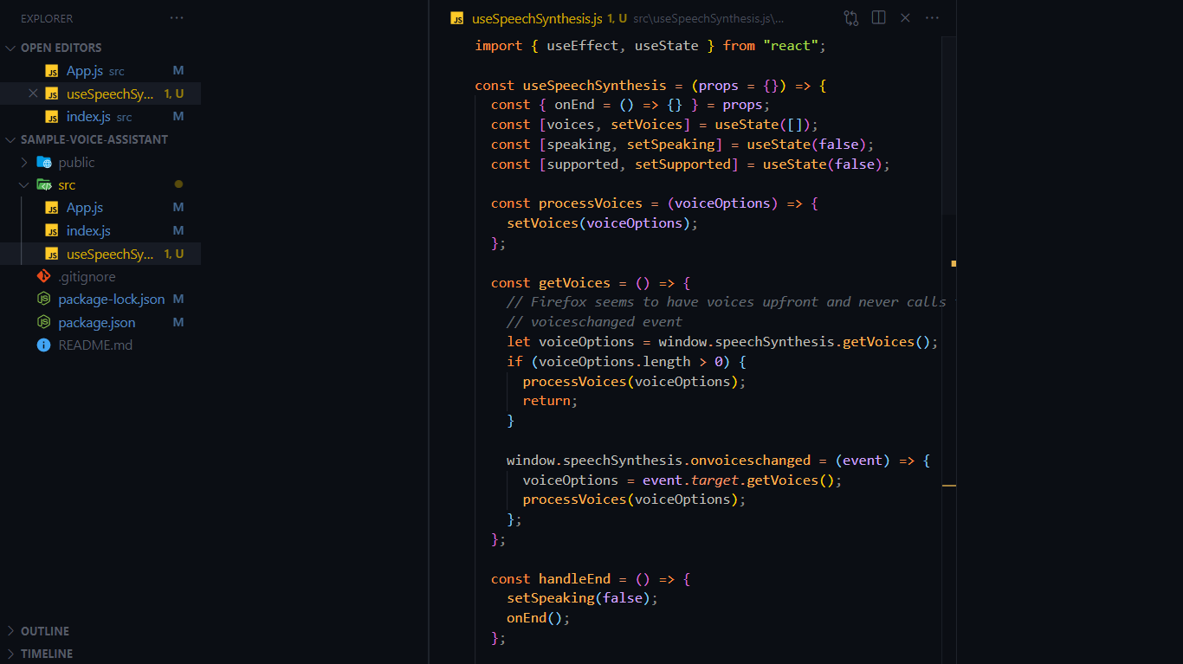

Figure 13 installing react-speech-kit step 4

5 - import useSpeechSynthesis in App.js file:

import SpeechRecognition, {

  useSpeechRecognition,

} from "react-speech-recognition";

*// new code*

import useSpeechSynthesis from "./useSpeechSynthesis";

*// end of the new code*

function App() {

...

Let test useSpeachSynthesis now, we need to update App.js again, add the follow code to App.js:

*//start of new code*

import { useEffect } from "react";

*// end of the new code*

import SpeechRecognition, {

  useSpeechRecognition,

} from "react-speech-recognition";

import useSpeechSynthesis from "./useSpeechSynthesis";

function App() {

  const {

    transcript,

    listening,

*//start of new code*

    finalTranscript,

*// end of the new code*

    resetTranscript,

    browserSupportsSpeechRecognition,

  } = useSpeechRecognition();

*//start of new code*

  const { speak, voices } = useSpeechSynthesis();

  useEffect(() => {

    if (finalTranscript) {

      if (finalTranscript === "can you hear me") {

        speak({

          text: "yes, I can , and congratulations for your first voice assistant app",

          voice: voices[7],

        });

        console.log({ finalTranscript });

      } else {

        console.log("i don't understand");

        speak({

          text: "i don't understand",

          voice: voices[7],

        });

      }

    }

*// eslint-disable-next-line react-hooks/exhaustive-deps*

  }, [finalTranscript]);

*// end of the new code*

  if (!browserSupportsSpeechRecognition) {

    return (

      <span>Browser doesn't support speech recognition.</span>

    );

  }

. . .

Now if you click on Start button and then say ‘can you here me’ you should hear ‘yes, I can , and congratulations for your first voice assistant app’:

### Your first voice assistant

Let’s now add two more commands to change the background color by adding the following code in App.js:

Importing useState hook from react:

*//start of new code*

import { useEffect, useState } from "react";

*// end of the new code*

*. . .*

Creating bgColor state and creating changeBGColor function:

. . .

  const { speak, voices } = useSpeechSynthesis();

*//start of new code*

  const [bgColor, setBgColor] = useState("white");

  const changeBGColor = (color) => {

    speak({

      text: `changing background to ${color}`,

      voice: voices[7],

    });

  };

*// end of the new code*

creating ‘change the background to red’ command and ‘change the background to white’ command:

useEffect(() => {

    if (finalTranscript) {

      if (finalTranscript === "can you hear me") {

        speak({

          text: "yes, I can , and congratulations for your first voice assistant app",

          voice: voices[7],

        });

        console.log({ finalTranscript });

      }

*//start of new code*

      else if (

        finalTranscript === "change the background to red"

      ) {

        changeBGColor("red");

        setBgColor("red");

      } else if (

        finalTranscript === "change the background to White" ||

        finalTranscript === "change the background to white"

      ) {

        changeBGColor("white");

        setBgColor("white");

      }

*// end of the new code*

      else {

        console.log("i don't understand");

        speak({

          text: "i don't understand",

          voice: voices[7],

        });

      }

}

. . .

Adding bgColor to main div’s style

. . .

const commonStyle = {

    display: "flex",

    justifyContent: "center",

    alignItems: "center",

    gap: "10px",

  };

  return (

    <div

      style={{

        ...commonStyle,

        flexDirection: "column",

        height: "100vh",

*//start of new code*

        background: bgColor,

*// end of the new code*

      }}

    >

      <p>Microphone: {listening ? "on" : "off"}</p>

. . .

Now if you click on Start button and then say ‘change the background to red’ you should hear ‘changing background to red’ and the background should change to red like the following image:

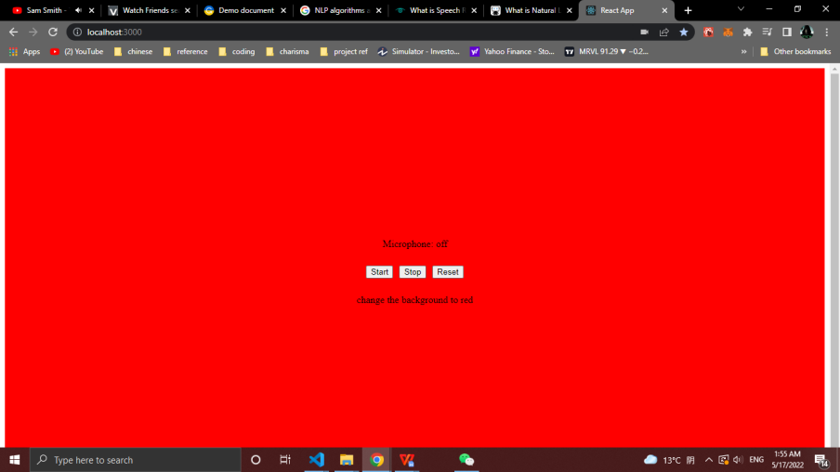

Figure 14 final Result for simple-voice-assistant

the full source code for this simple voice assistant in the following GitHub:

<https://github.com/nur1208/simple-voice-assistant>

# REQUIREMENTS ANALYSIS

## Functional requirement

The modules involved are:

* + - User Management
    - Stock Market News
    - Stock Information
    - Speech recognition
    - Controlling the app with a voice
    - Speech synthesis
    - Asking questions about the stock market
    - Back-testing stock trading strategy
    - Automating stock trading  **(**Trading bot**)**

**User management** module contains all functionality related to users. a user can register to the app, can log in, can update his/her information, can update his/her password, can add and remove stocks from his/her watch list, and if a user forgets his/her password a user can create a new password by receiving a reset token in his/her email.

**The Stock Market News** module contains all functionality related to the news. getting news by source, keyword in the headline, latest or top stories. Get more news. scraping news from yahoo finance, google finance, investing, and seeking websites. saving scraped news in the database. letting Finansis start reading news headlines from the first article, start reading them from specific article's number, or stop reading them. opening article's details page with help of Finansis or without, if a window opened with Finansis’s help, Finansis can scroll the window.

**Stock information** module contains all functionality related to stock information. opening stock chart using yahoo finance's charts with Finansis's help or without, if the chart is opened with Finansis's help, Finansis can change the chart's type daily, 1 minute, or whatever valid type, and Finansis can also zoom the chart in or out. opening multiple charts at once only without Finansis's help. Get the stock's current price (real-time price) for free using the following API (URL: [14]). Helping Finansis to learn about companies. showing users the most active, gainers, or losers stocks by opening yahoo finance stocks screeners. showing users a stock statistics by opening yahoo finance stock statistics section. showing users sold stocks by opening yahoo finance stock chart and then changing the date range to equal date of buying and selling of the sold stock.

**Speech recognition** module enable users to speak to Finansis and Finansis understand them, Speech Recognition module is the most important module in this project, I used react-speech-recognition package which uses Web speech API. Speech Recognition model is create by w3c community group[16][17].

**Controlling the app with a voice** module is to control the app by telling Finansis commands using Speech recognition module. navigating between pages by telling finansis 'go forward', 'go back' or 'go to {news|info|...} page' ({news|info|..} is dynamic values, for example: 'go to news page'). zooming in or out charts, scrolling news page, scrolling details news page. closing any popup window.

**Speech synthesis** module is to make Finansis speak out loud. responding to users, asking users yes/no questions, or asking users to choose a stock from a stock list. stopping Finansis from recognizing when Finansis start speaking out loud.

**Back-testing stock trading strategy** module is to let users test stock trading strategy of this application. users will input start date, end date, initial cash, and account risk per trade. helping developers of this app to come up with a better trading strategy. I will talk about back-testing later in this thesis.

**Asking questions about the stock market** module is to let users ask questions about the stock market and then Finansis answers the question, if the answer of the question not exist in the database, then Finansis will search in the DuckduckGo (a search engine like Google) and after that save the answer in the database and lastly answer the question so if someone asked the same question again Finansis just answer it.

**Automating stock trading (Trading Bot)** module is to let Finansis buy, sell and set stop loss for stocks using Algorithmic Trading. the trading flow first set stop loss for bought stocks, second find sell signals for bought stocks and then sell them if a signal has been found, third scrap S&P 500 stocks, and then save them in python array, fourth loop through all S&P 500 stocks to find buy signals then save them in the database if a signal has been found, lastly, get found buy signal stocks from the database and then buy them. in this project for current version 1.0 all buy and sell stocks in a simulator for the stock market I used Investopedia's simulator (URL: [18]).

# SYSTEM DESIGN

Software design sits at the technical kernel of the software engineering process and is applied regardless of the development paradigm and area of application. Design is the first step in the development phase for any engineered product or system. The designer’s goal is to produce a model or representation of an entity that will later be built. Beginning, once system requirement has been specified and analyzed, system design is the first of the three technical activities - design, code and test that is required to build and verify software.

During design, progressive refinement of data structure, program structure, and procedural details are developed reviewed and documented. System design can be viewed from either technical or project management perspective. From the technical point of view, design is comprised of four activities – architectural design, data structure design, interface design and procedural design.

## System structure diagram

A System Structure Diagram is a type of UML Class Diagram. This model highlights the systems within a system. The following Diagram is Finansis’s Structure Diagram

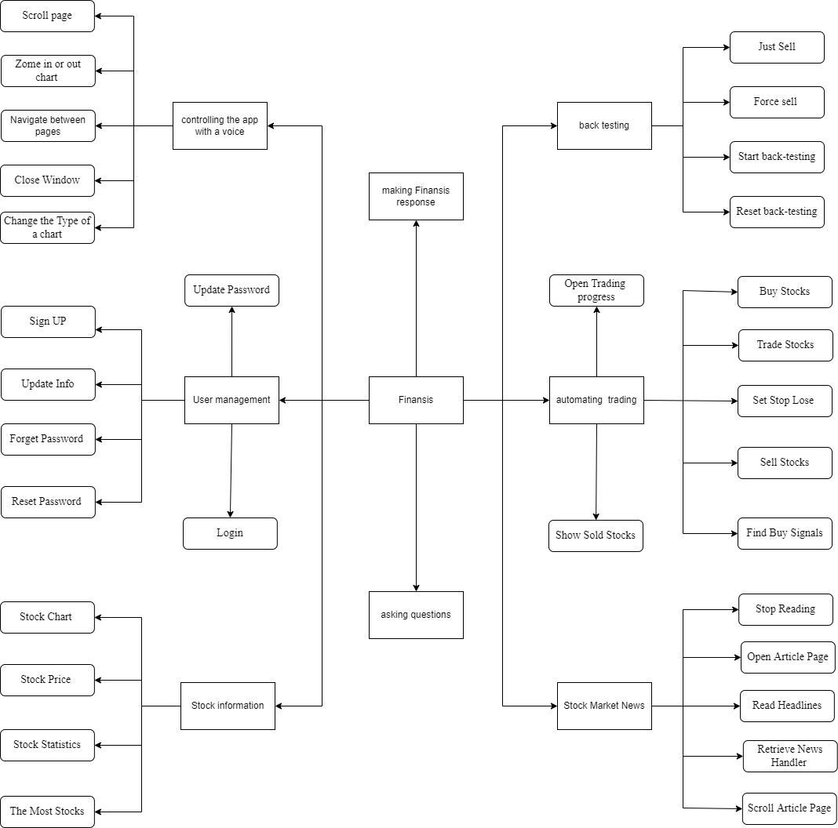

Figure 15 System structure diagram

## Data flow graph

### The first data flow graph

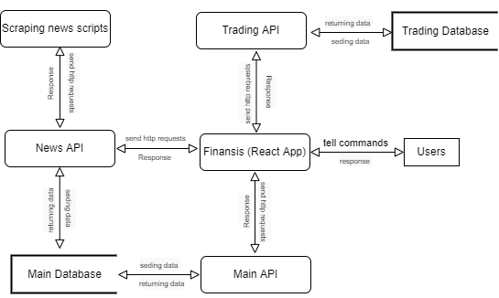

Figure 16 DFD-1

### The second data flow graph

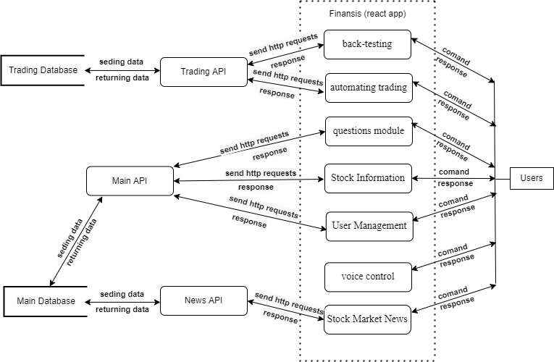

Figure 17 DFD-2FD-2

### The third data flow graph

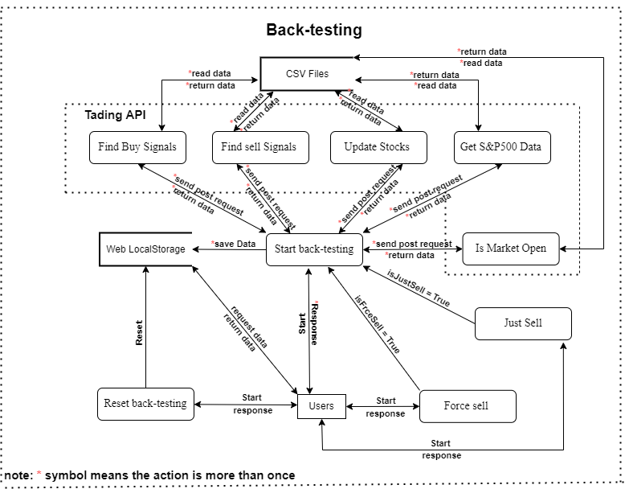

Figure 18 DFD (Back-Testing)-3-1

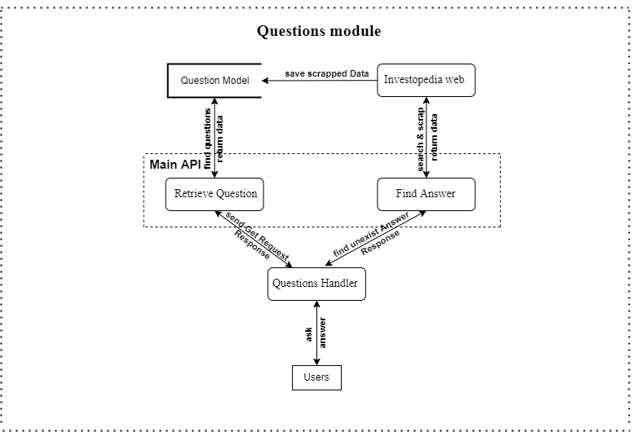

Figure 19 DFD (Questions)-3-2

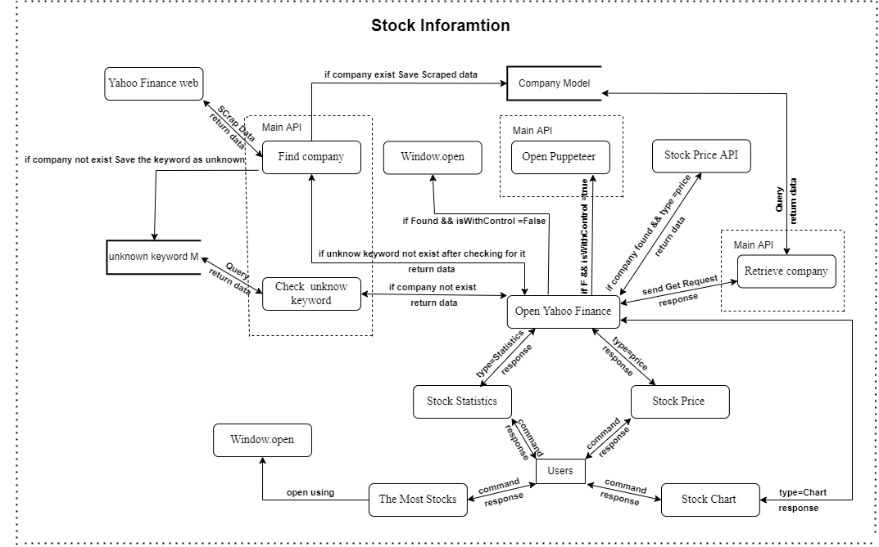

Figure 20 DFD (Stock Info)-3-3

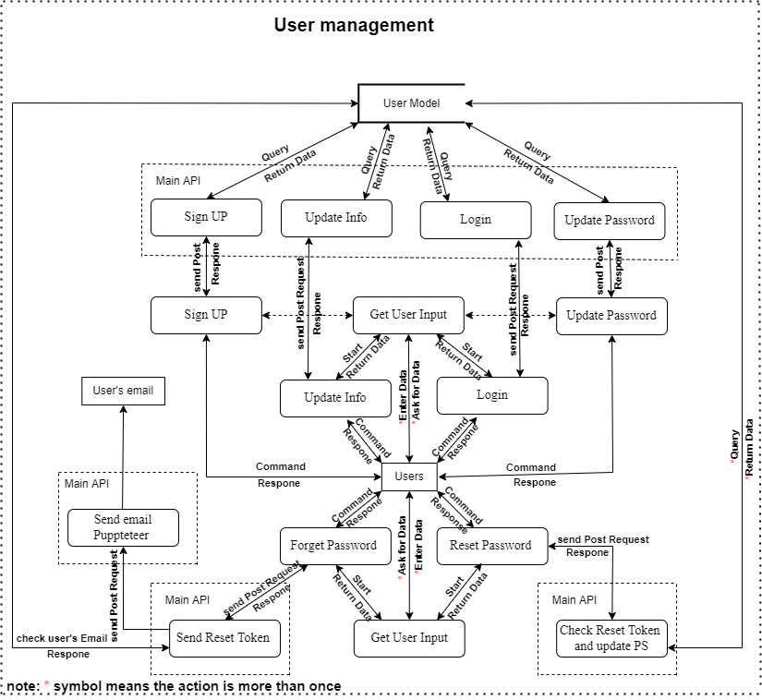

Figure 21 DFD (User Management)-3-4

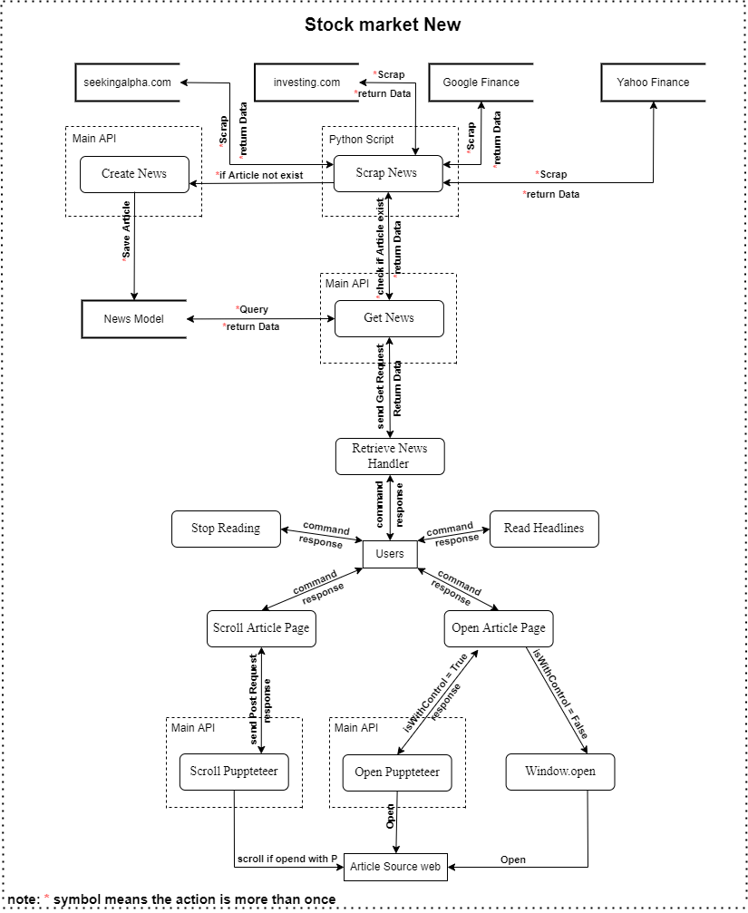

Figure 22 DFD (Stock Market News)-3-5

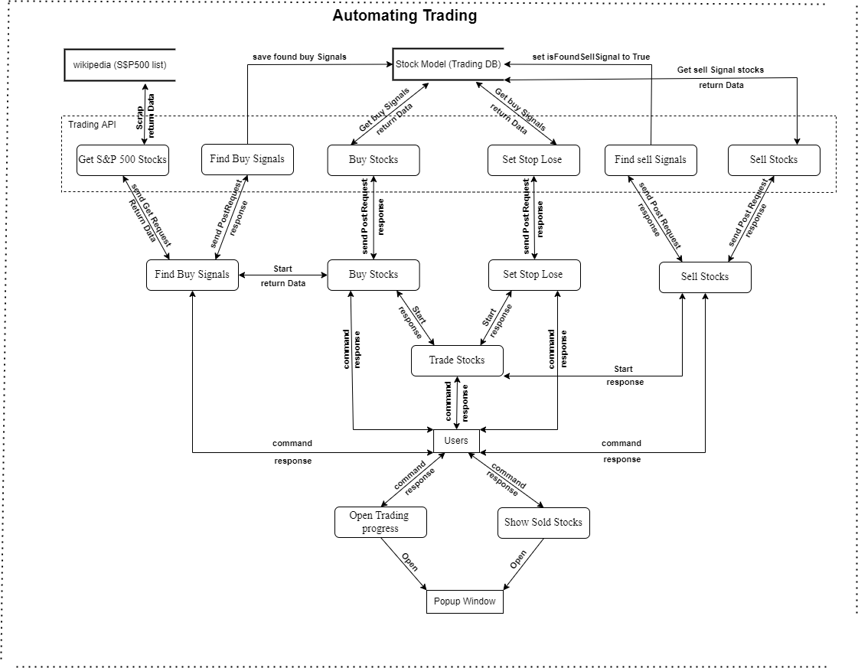

Figure 23 DFD (automating trading)-3-6

## System flow chart

### Getting news flow chart

as a user looking to read news headlines or letting Finansis read them for him, he can command ‘give me the news from {Yahoo Finansis}’ the next stop would be for Finansis to make a call to News API to fetch news for the database, and then display the news to the user, if didn’t find news so then tell him ‘sorry, I didn't find news from {source} ‘ (See Figure 24 below)

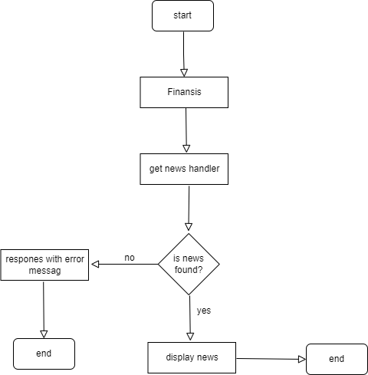

Figure 24 getting news flow chart

### Asking question flow chart

a user ask a question for example ‘what is market capitalization’, if an answer for the question is exist so then answer the user, otherwise ask a user ‘do you want me to find answer for 'what is market capitalization', if a user answer is yes so then scrap an answer and then answer the user otherwise end this process. (See Figure 25 below)

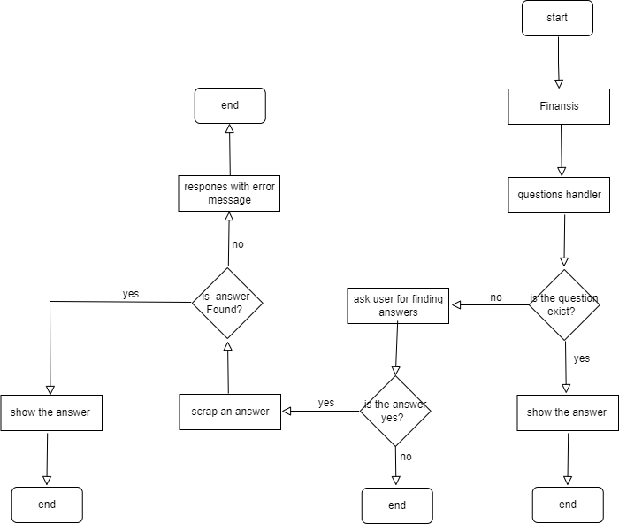

Figure 25 asking question flow chart

### Opening chart flow chart

a user command "open Apple chart’' if found a stock for apple in the database so then open Apple chart otherwise ask a user ‘do you want me to learn about {apple} company’ if a user answer is ‘yes’ so then search for the symbol and then scrap it if the symbol found open the chart otherwise save the symbol as an unknown keyword in the database and then end this process. (See Figure 26 below)

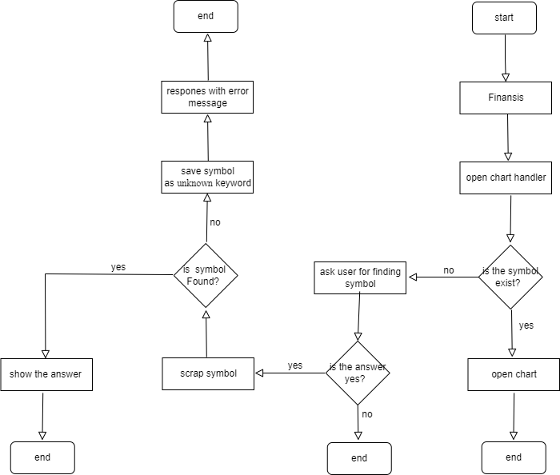

Figure 26 opening chart flow chart

### Starting back-testing flow chart

A user command ‘start back-testing, so then Finansis will call startBacktesting function, in the function first it will send a request to ‘is market open’ endpoint and if the request returns an error so then send the request again and only go to the next step if the request sent successfully and the same process for ‘get sp500 data’ endpoint, ‘update current price’ endpoint, ‘sell stocks’ endpoint and ‘buy stocks’ endpoint, only stop this process when start date equal end date. (See Figure 27 below)

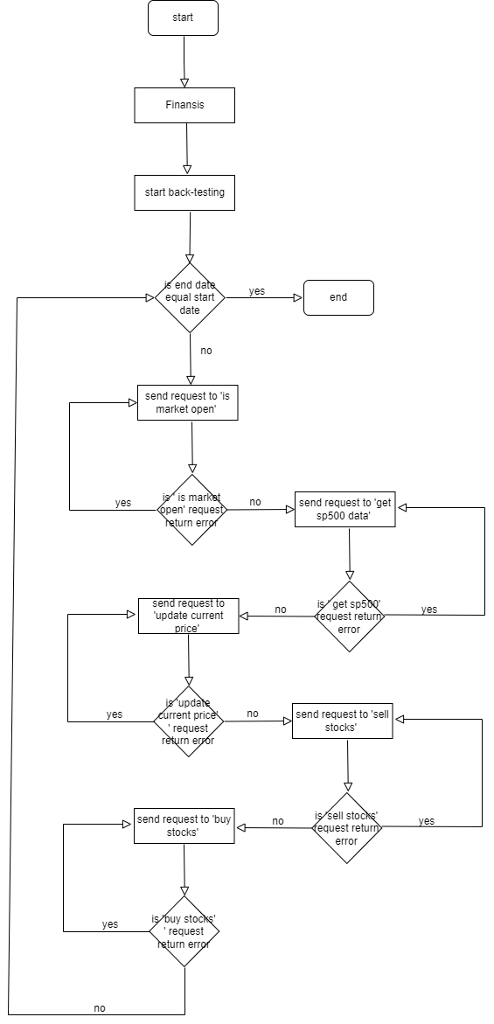

Figure 27 start back-testing flow chart

### Zooming in or out flow chart

A user command ‘zoom in’ or ‘zoom out’, first check if the zooming type is valid (valid options in or out) if the condition is false so stop this process, otherwise go to the next step which is to check if a chart window is open using puppeteer, if the condition is false so stop this process, otherwise zoom in or out the chart. (See Figure 28 below)

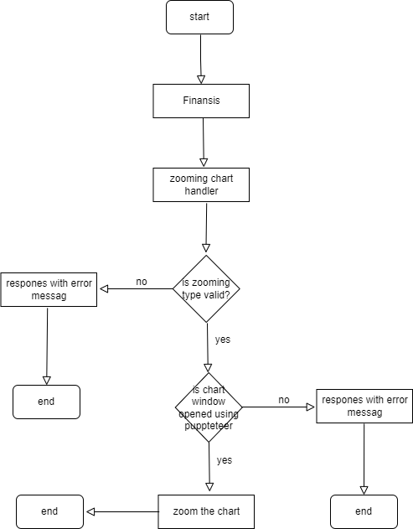

Figure 28 zooming in or out flow chart

### Buy stocks flow chart

A User commands ‘buy stocks’, so then Finansis will call buy stocks handler, which will call find buy signals handler, in find buy signals handler first it will send request to ‘save sp500 stocks’ endpoint, if the request returned an error so then stop this process otherwise send request to ‘find buy signals’ endpoint if the request returned an error so then stop this process otherwise return total number of found buy signals to buy stocks handler, if didn’t find any buy signal so then stop this process otherwise send request to ‘buy stocks’ endpoint to buy stocks using puppeteer automation functionality. (See Figure 29 below)

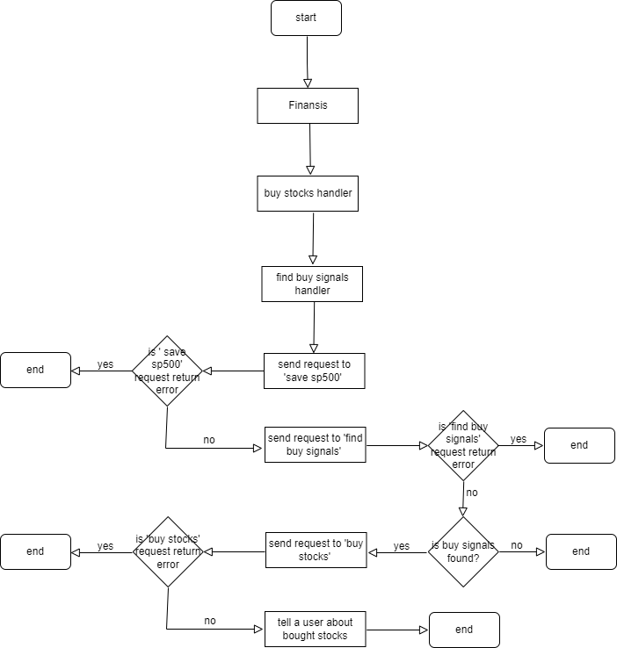

Figure 29 buy stock flow chart

### Sell stocks flow chart

A user command ‘sell stocks’, so then Finansis will call sell stocks handler, which will send a request to ‘find sell signals’ endpoint and if found sell signals so then send a request to‘sell stock’ endpoint to sell stock using puppeteer automation functionality, if any of the previous requests return an error so then ask a user ‘do you want me to try to sell again’ if the user says ‘yes’ call sell handler again, otherwise stop this process. (See Figure 30 below)

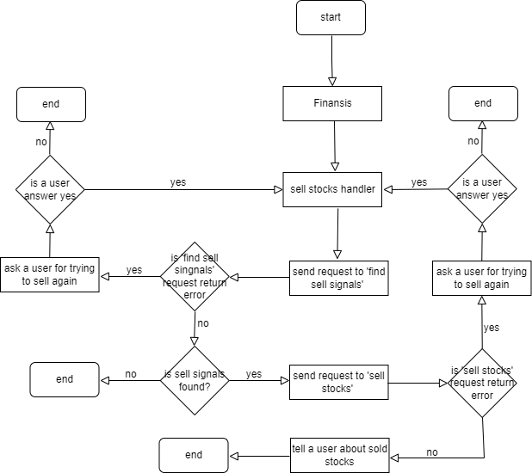

Figure 30 sell stocks flow chart

## Commands description:

note:

- if a word between () that means the word is optional.

- if a word between {} that means the word is dynamic.

- | is separator between the dynamic options for a command.

- ... means that there is more dynamic options then words inside {}.

### User management commands (10):

* sign up
* login
* forgot (my) password
* update my information
* logout
* update (my) password
* add {Apple|AAPL|...} stock to (my) watch list
* delete {Apple|AAPL|...} stock from (my) watch list
* open (my) watch list

### Stock Market News commands (10):

* Give me the news from {yahoo finance|investing|seekingalpha}
* open article (number) {1|5|...}
* what's up with {Apple|China|...}
* Give me the latest news
* read the news
* give me more news
* start reading (news) from article {1|5|...}
* open article (number) {1|5|...} without control
* give me top stories
* give me {Apple|AAPL|...} stock news

### Stock information commands (9):

* open {Apple|AAPL|...} (symbol) chart
* give me {Apple|AAPL|...} statistics
* give me The most {actives|gainers|losers} stocks
* give me trending stocks
* open {Apple|AAPL|...} (symbol) chart with your control
* what is the current price for {Apple|AAPL|...} (symbol)
* show me {Apple and Tesla|AAPL and DD|Apple and Tesla and amazon|...} charts

### controlling the app with a voice commands (5):

* go back
* go to {info|news|...} (page)
* close the window
* zoom {in|out}
* change the chart to {1 minute|1 hour|...}

### asking questions about the stock market commands:

* open details page for the answer
* what is market capitalization
* other questions exist in the database
* and any unknown command start with 'how' or 'what'

### back-testing stock trading strategy commands (4):

* start back testing
* reset back testing (data)
* force sell
* sell with profit or without

### other commands (10):

* stock (number) {1|5|...}
* what can you do
* what is your name
* (of course) yes
* no
* do you have a boyfriend
* can you hear me
* stop listening
* thank you
* what's the date today

### automating stock trading commands (8):

* buy stocks
* sell stocks
* set stop-loss for stocks
* trade stocks for me
* find buy signals
* show me (a) chart for found buy signals (stocks)
* sold stocks chart
* show me trading progress

# Testing

Software Testing is a method to check whether the actual software product matches expected requirements and to ensure that software product is Defect free. It involves execution of software/system components using manual or automated tools to evaluate one or more properties of interest. The purpose of software testing is to identify errors, gaps or missing requirements in contrast to actual requirements[1].

In this project I used manual testing.

* **Test case ID**

T1

* **Test case title**

Validate getting news by source successfully

* **Test steps**

- command ‘Give me the news from {yahoo finances}’

* **Test data**

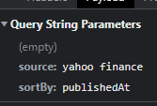

* **Expected result**

Responding ‘finding’

Showing a user news from Yahoo Finances

Responding ‘here is the news from Yahoo Finances’

Asking ‘do you want me to read the head lines’

* **Actual result**

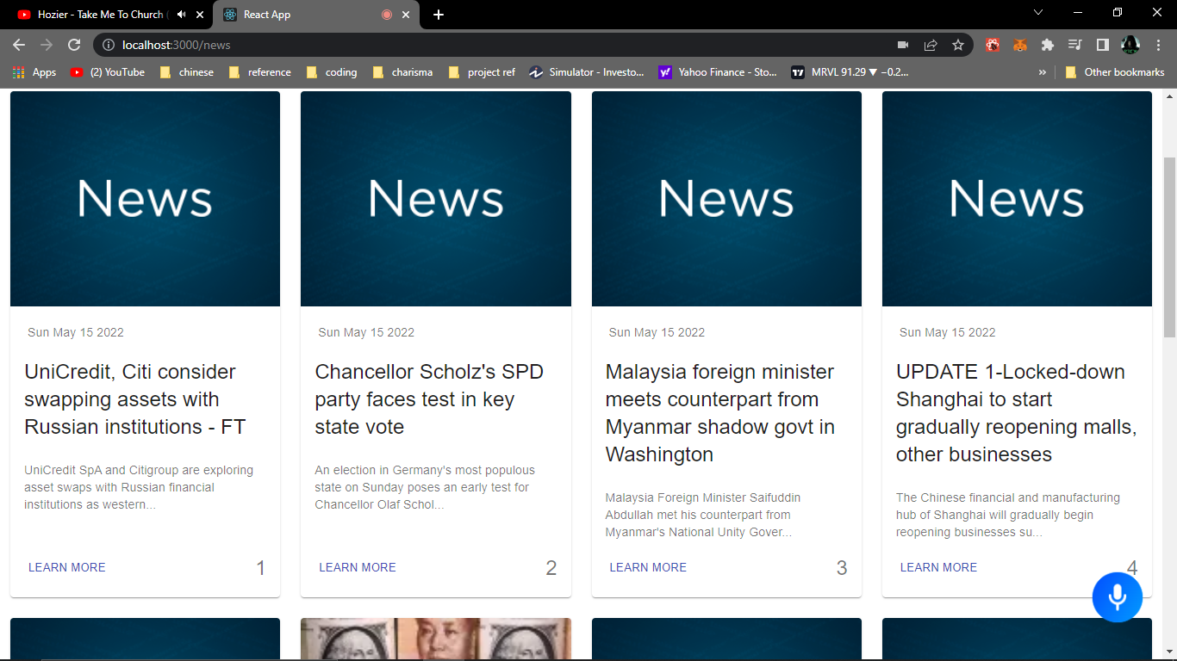

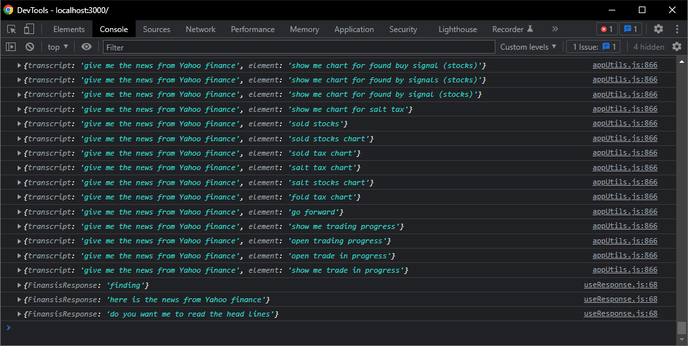

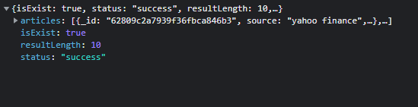

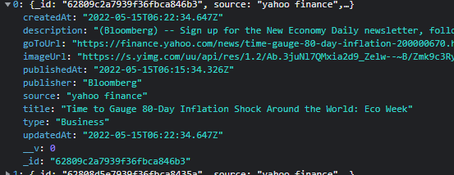

* **Conclusion**

**Pass**

* **Test case ID**

T2

* **Test case title**

Validate getting news by source Failing

* **Test steps**

- command ‘Give me the news from {CNN}’

* **Test data**

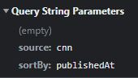

* **Expected result**

Responding ‘finding’

Responding ‘sorry, I didn't find news from {CNN}’

* **Actual result**

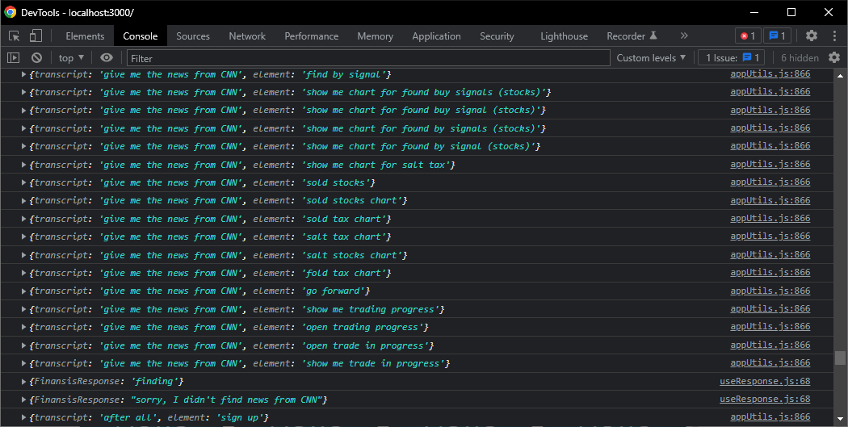

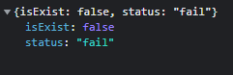

* **Conclusion**

**Pass**

* **Test case ID**

T3

* **Test case title**

Validate getting news by keyword in Title successfully

* **Test steps**

- command ‘what's up with {Shanghai}’

* **Test data**

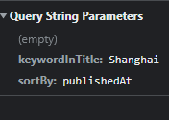

* **Expected result**

Responding ‘finding’

Showing a user news that has ‘Shanghai’ keyword in the head line

Responding ‘here is what's up with Shanghai’

Asking ‘do you want me to read the head lines’

* **Actual result**

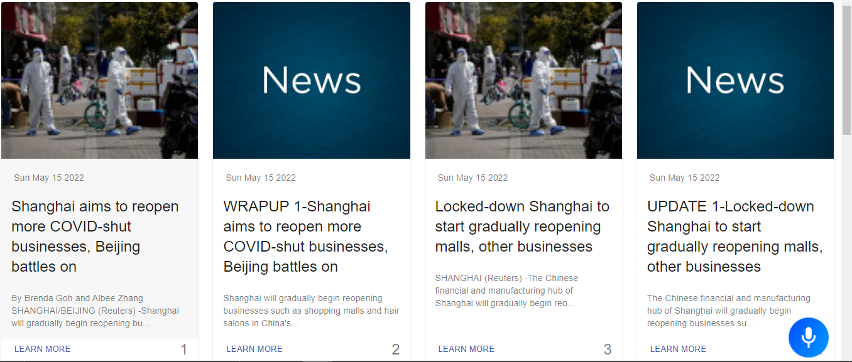

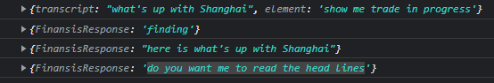

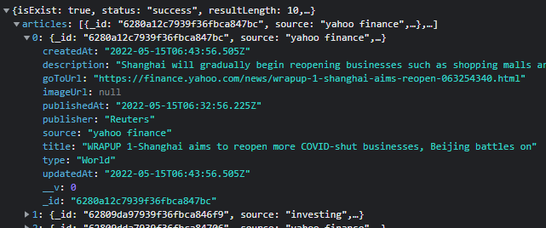

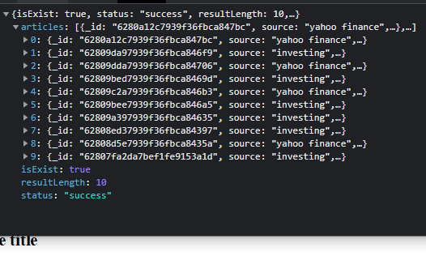

* **Conclusion**

**Pass**

* **Test case ID**

T4

* **Test case title**

Validate getting the latest News successfully

* **Test steps**

- command ‘give me the latest news’

* **Test data**

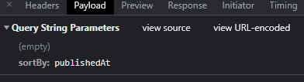

* **Expected result**

Responding ‘finding’

Showing a user the latest news

Responding ‘here is the latest news’

Asking ‘do you want me to read the head lines’

* **Actual result**

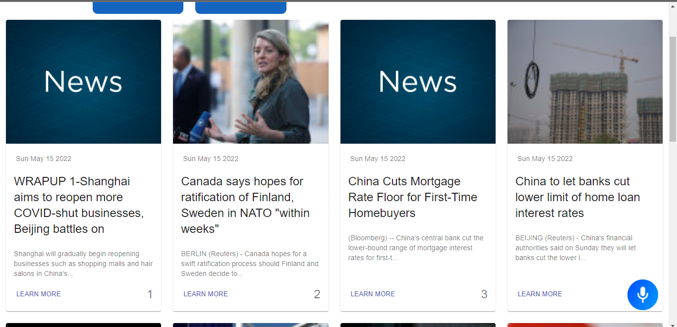

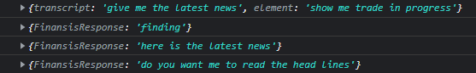

* **Conclusion**

**Pass**

* **Test case ID**

T5

* **Test case title**

Validate getting Top news successfully

* **Test steps**

- command ‘give me top stories’

* **Test data**

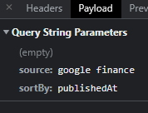

Google finance only shows top news by default

* **Expected result**

Responding ‘finding’

Showing a user top news

Responding ‘here is top news’

Asking ‘do you want me to read the head lines’

* **Actual result**

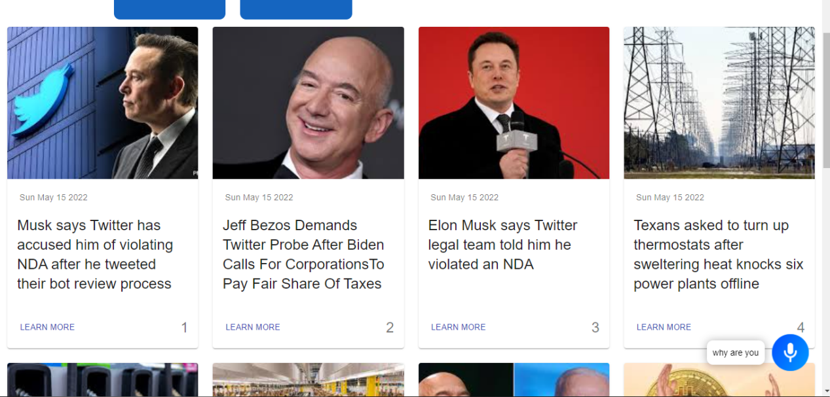

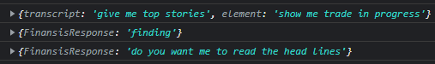

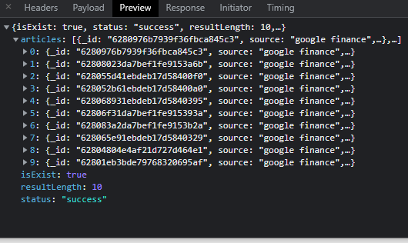

* **Conclusion**

**Failed**

Failed to Respond ‘here is top news’

* **Test case ID**

T6

* **Test case title**

Validate asking question in the database

* **Test steps**

- ask ‘what is market capitalization’

* **Test data**

what is market capitalization

* **Expected result**

- Opening popup window with the answer

- Responding ‘Market capitalization refers to how much a company is worth as determined by the stock market. It is defined as the total market value of all outstanding shares. value of all outstanding shares.’

- Closing popup window after answering the question

* **Actual result**

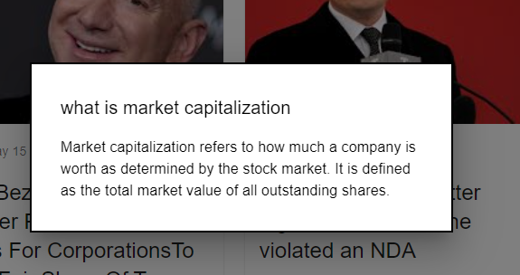

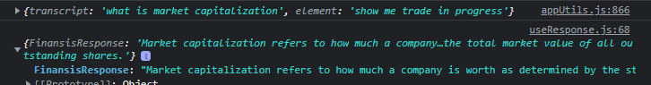

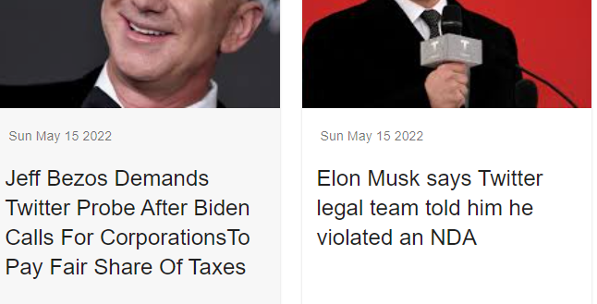

* **Conclusion**

**Pass**

* **Test case ID**

T7

* **Test case title**

Validate asking question not in the database

* **Test steps**

- ask ‘what is price-to-earning ratio’

* **Test data**

what is price-to-earning ratio

* **Expected result**

asking ‘do you want me to learn about what is price-to-earning ratio’

* **Actual result**



* **Conclusion**

**Pass**

* **Test case ID**

T8

* **Test case title**

Validate ‘yes’ answer for ‘do you want me to learn about what is price-to-earning ratio’ question

* **Test steps**

- answer ‘Yes’

* **Test data**

Yes

* **Expected result**

- Responding ‘give me a minute to find an answer’

- opening DuckDuckGo search engine using puppeteer

- searching ‘what is price-to-earning ratio investopedia’

- clicking at the first result

- scrap the answer from investopedia website

- save the question in the database

- Opening popup window with the answer

- Answering the question

- Closing popup window after answering the question

* **Actual result**

Before:

MongoDB:

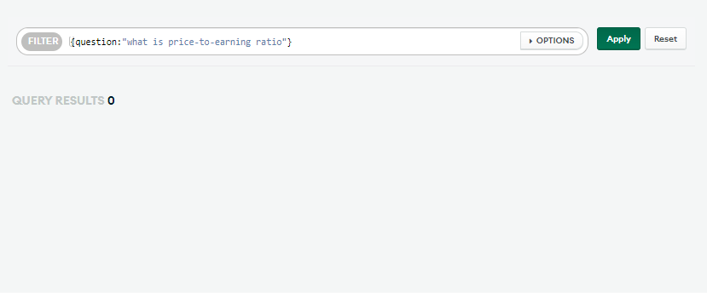



After:

Sending request to AUTO API’s ‘FindingAnswers endpoint”:

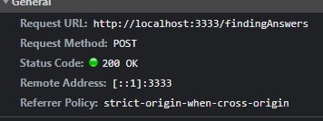

Searching in DuckDuckGo:

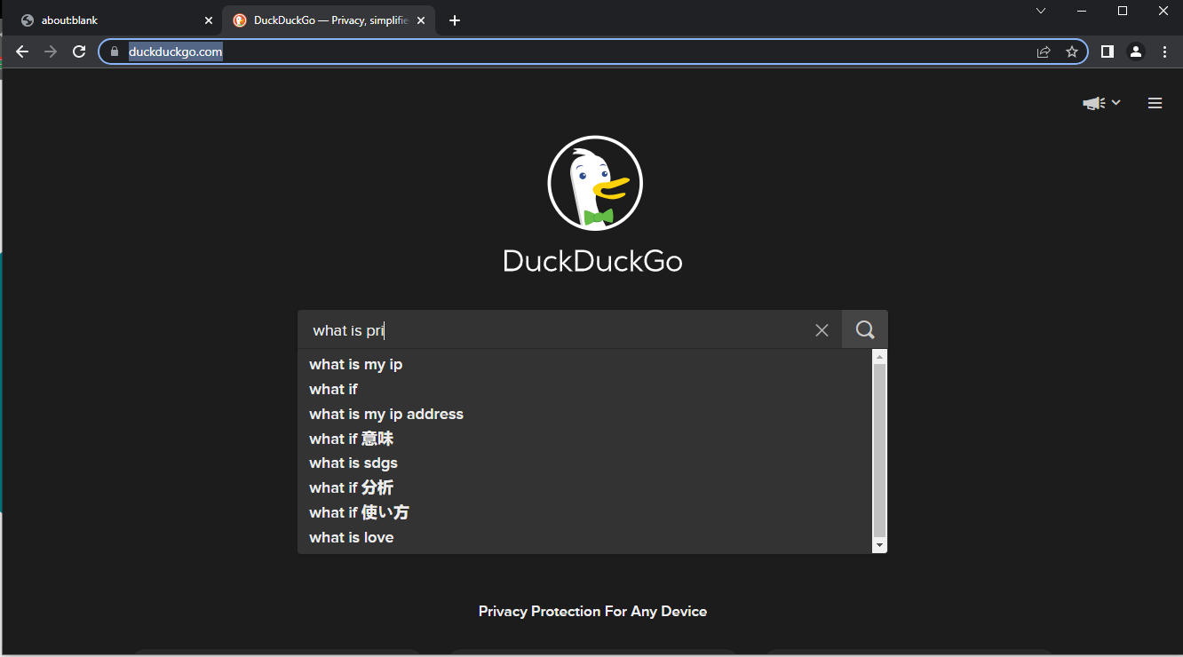

Response from AUTO API:

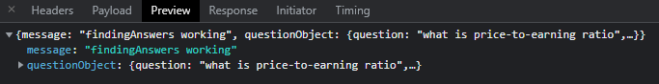

MongoDB:

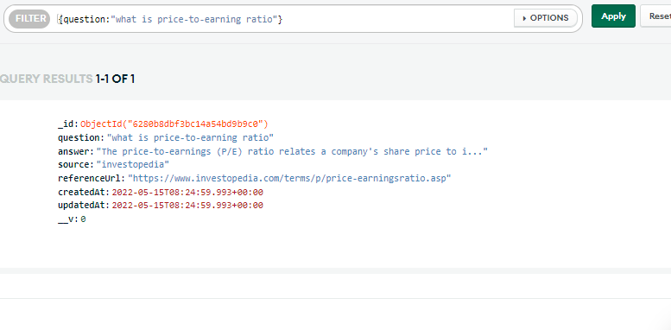

Opening popup window with the answer:

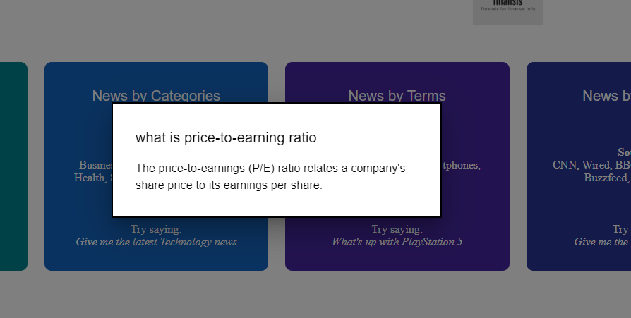



* **Conclusion**

Pass

* **Test case ID**

T9

* **Test case title**

Validate opening chart successfully

* **Test steps**

- command ‘open Apple chart’

* **Test data**

open Apple chart

* **Expected result**

- Opening popup window with list of stocks

- Asking ‘found the following stocks choose one by saying stock number 3 for example’

- Responding ‘opening AAPL chart’

* **Actual result**

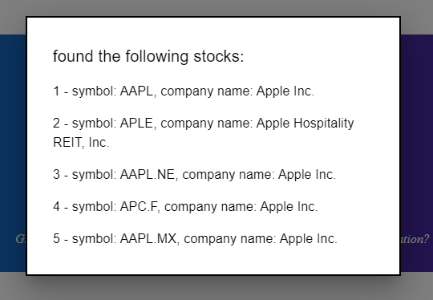





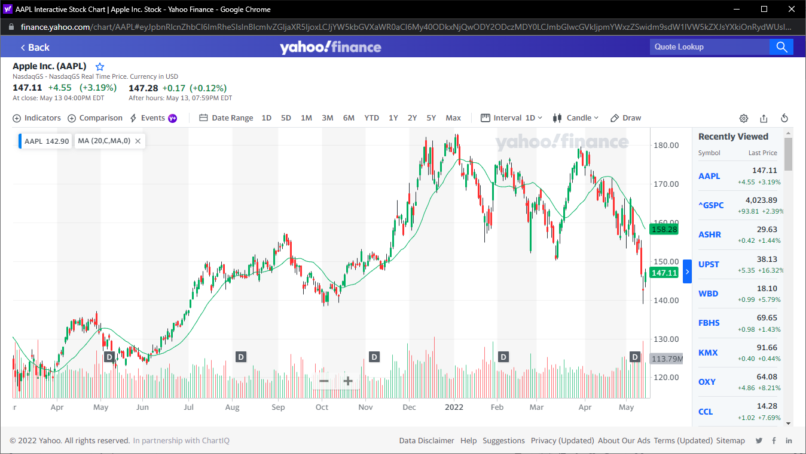

* **Conclusion**

pass

* **Test case ID**

T10

* **Test case title**

Validate opening multiple successfully

* **Test steps**

- command ‘open Apple and Tesla charts’

* **Test data**

open Apple and Tesla charts

* **Expected result**

Responding ‘opening Apple chart’

Opening Apple chart

Responding ‘opening Tesla chart’

Opening Tesla chart

* **Actual result**



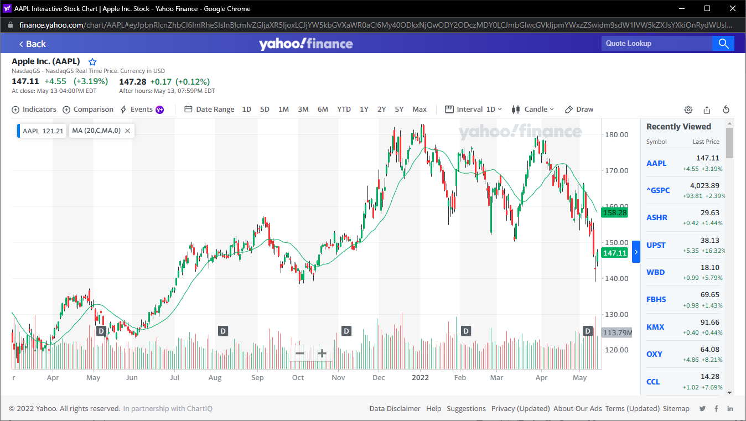



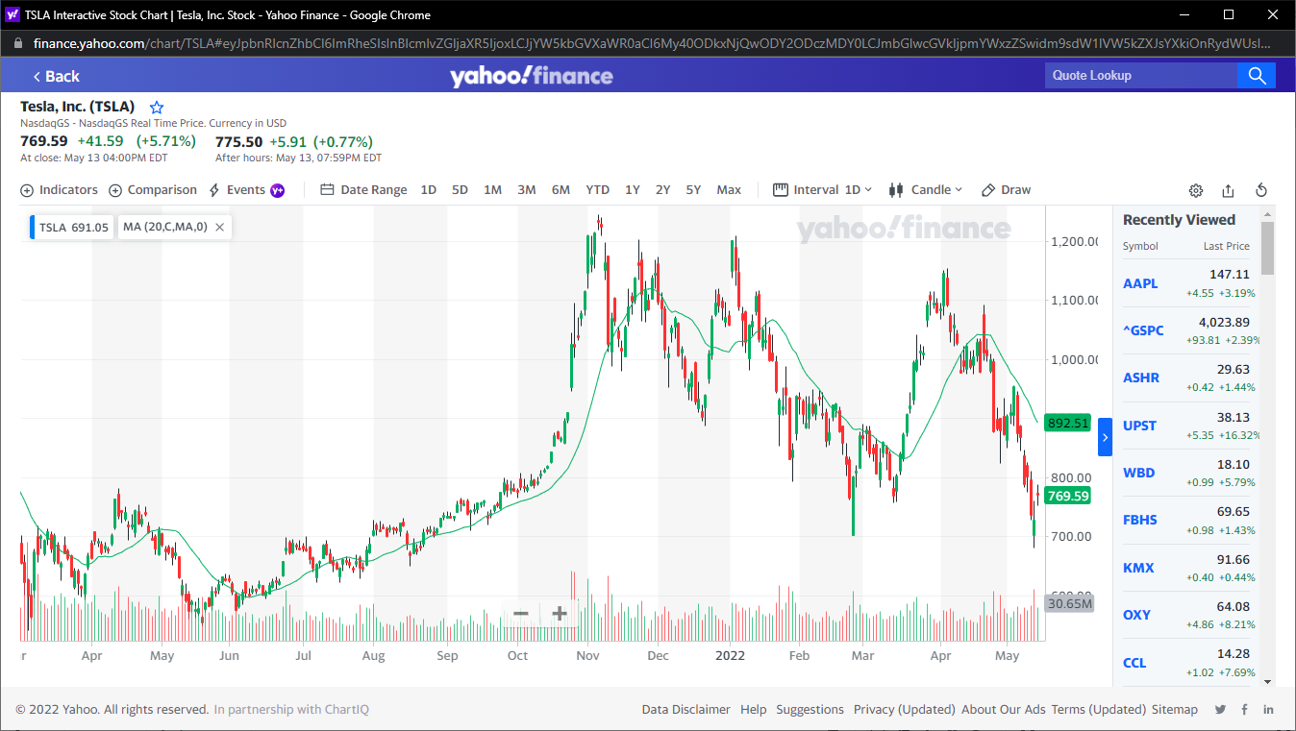

* **Conclusion**

pass

* **Test case ID**

T11

* **Test case title**

Validate getting the most activate stocks successfully

* **Test steps**

- command ‘give me the most active stocks’

* **Test data**

give me the most active stocks

* **Expected result**

Responding ‘here is the most actives stocks from yahoo finance’

Opening ‘Most activate stocks’ window

* **Actual result**



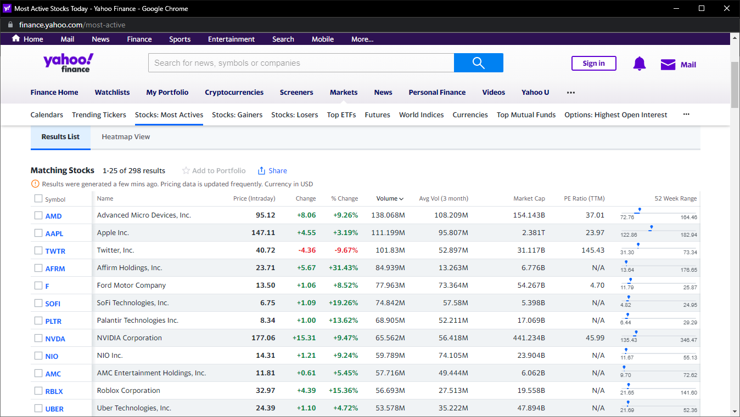

* **Conclusion**

pass

* **Test case ID**

T11

* **Test case title**

Validate opening chart with Finansis controller successfully

* **Test steps**

- command ‘open apple Chart with your control’

* **Test data**

open apple chart with your control

* **Expected result**

- Opening popup window with list of stocks

- Asking ‘found the following stocks choose one by saying stock number 3 for example’

- Responding ‘opening AAPL chart’

- Responding “loading the page will take seconds”

Opening AAPL chart using puppeteer

- Responding “the page is done loading”

* **Actual result**

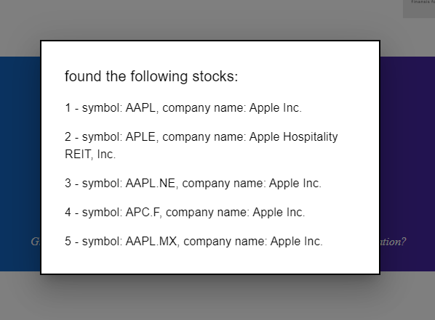



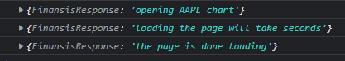

Send request to Auto API with the following payload:

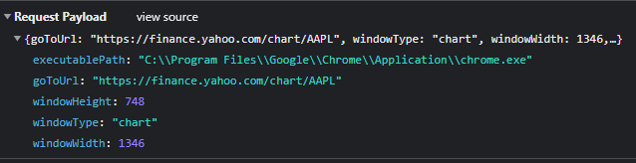

Auto API log:



Opened window:

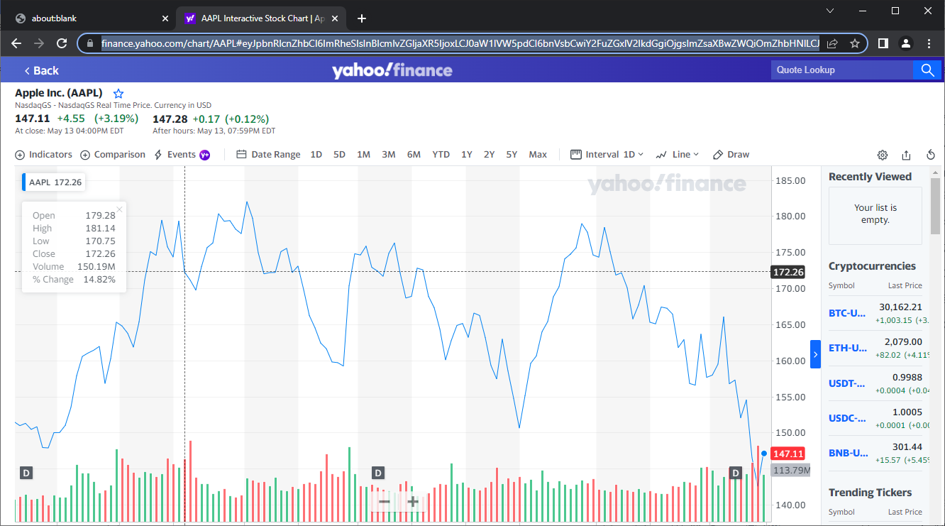

* **Conclusion**

pass

* **Test case ID**

T12

* **Test case title**

Validate zooming in a chart opened using puppeteer successfully

* **Test steps**

- command ‘zoom in’ five times

* **Test data**

zoom in

* **Expected result**

- Responding ‘zooming in’

- zooming the chart in

* **Actual result**

Before:

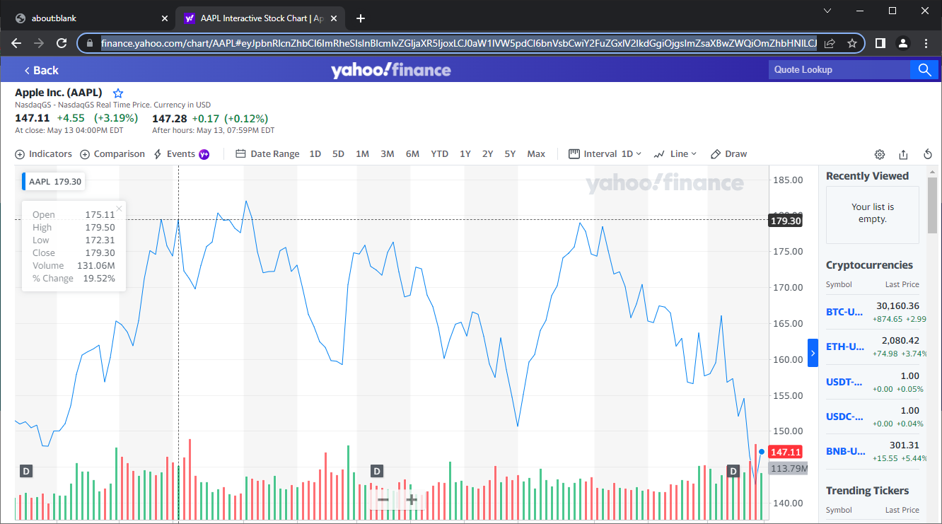

After:

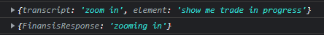

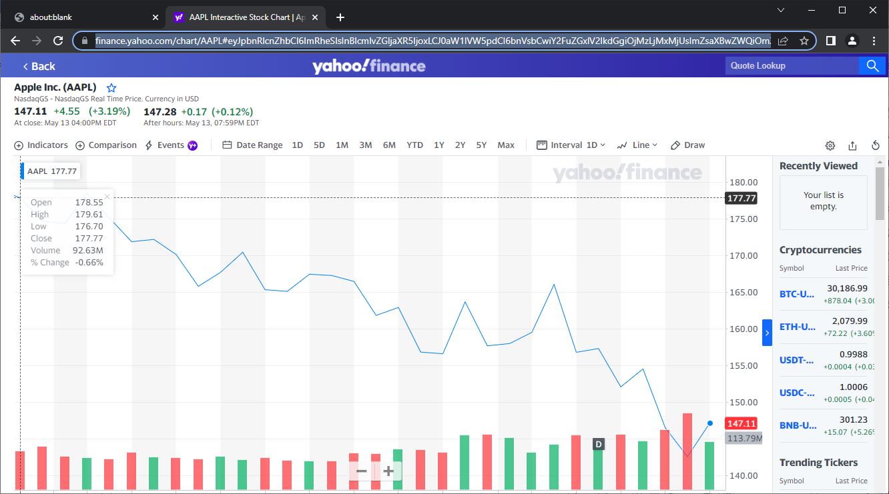

* **Conclusion**

pass

* **Test case ID**

T5

* **Test case title**

Validate getting Top news

* **Test steps**

- command ‘give me top stories’

* **Test data**



Google finance only shows top news by default

* **Expected result**

Responding ‘finding’

Showing a user top news

Responding ‘here is top news’

Asking ‘do you want me to read the head lines’

* **Actual result**



* **Conclusion**

**Failed**

Failed to Respond ‘here is top news’

* **Test case ID**

T5

* **Test case title**

Validate getting Top news

* **Test steps**

- command ‘give me top stories’

* **Test data**



Google finance only shows top news by default

* **Expected result**

Responding ‘finding’

Showing a user top news

Responding ‘here is top news’

Asking ‘do you want me to read the head lines’

* **Actual result**



* **Conclusion**

**Failed**

Failed to Respond ‘here is top news’

* **Test case ID**

T5

* **Test case title**

Validate getting Top news

* **Test steps**

- command ‘give me top stories’

* **Test data**



Google finance only shows top news by default

* **Expected result**

Responding ‘finding’

Showing a user top news

Responding ‘here is top news’

Asking ‘do you want me to read the head lines’

* **Actual result**



* **Conclusion**

**Failed**

Failed to Respond ‘here is top news’

* **Test case ID**

T5

* **Test case title**

Validate getting Top news

* **Test steps**

- command ‘give me top stories’

* **Test data**



Google finance only shows top news by default

* **Expected result**

Responding ‘finding’

Showing a user top news

Responding ‘here is top news’

Asking ‘do you want me to read the head lines’

* **Actual result**



* **Conclusion**

**Failed**

Failed to Respond ‘here is top news’

# Conclusion

thanks to every teacher who taught me something about computer science in Wenzhou or on the internet, thanks to each programmer on StackOverflow that help me or build technologies I used in this project, and special thanks to Wingo Laoshi that help me to come up with Finansis idea by telling me my old idea is not reasonable which was creating 'stock market production model' using machine learning. I will keep working on this project, and keep researching for good developers to build and improve the project, and one day we will take Finansis project from a final project for Degree of Bachelor to a real business that anyone interested in the stock market or making passive income can use Finansis.

## Future Goals For The System overview

* Improving UI design.
* Trading stocks with real money.
* Making the System online.
* Creating our own voice Recognition AI.
* Adding more commands to control the System.
* Making Finansis understand other Languages (Arabic and Chinese)
* Adding Smart Contracts

## Drawback of Existing system

* Existing system is failing in providing high security
* The website design is not good
* Trading stock with fake money.
* Finansis is offline (only run in developer localhost)
* Finansis Can only work in Chrome Browser
* Finansis can’t know that ‘what is’ and ‘what’s’ are the same

# REFERENCE

[1] Guru99 https://www.guru99.com/software-testing-introduction-importance.html.

[2] https://www.techtarget.com/searchcustomerexperience/definition/speech-recognition.

[3]https://www.datarobot.com/blog/what-is-natural-language-processing-introduction-to-nlp/

[4] Wikipedia https://en.wikipedia.org/wiki/Python_(programming_language).

[5] Wikipedia https://en.wikipedia.org/wiki/Front-end_web_development.

[6] Guru99 https://www.guru99.com/what-is-backend-developer.html.

[7] Investopedia https://www.investopedia.com/terms/a/algorithmictrading.asp.

[8] Youtube https://www.youtube.com/watch?v=p7HKvqRI_Bo.

[9] investopedia https://www.investopedia.com/ask/answers/155.asp.

[10] icicidirect <https://www.icicidirect.com/knowledge-center/article/risk-management-in-stock-market.>

[11]https://www.digitalocean.com/community/tutorials/how-to-use-node-js-modules-with-npm-and-package-json

[12] <https://www.emarketer.com/content/voice-assistant-and-smart-speaker-users-2020>

[13] [https://news-api-lovat.vercel.app/api/v1/news](https://news-api-lovat.vercel.app/api/v1/news).)

[14] <https://replit.com/@mHmdnwr/Chromium-Advanced-5ad#main.py>

[15] <https://yahoo-finance-api.vercel.app/AAPL>

[16] <https://www.google.com/intl/en/chrome/demos/speech.html>

[17] <https://wicg.github.io/speech-api/>

[18] <https://www.investopedia.com/simulator>